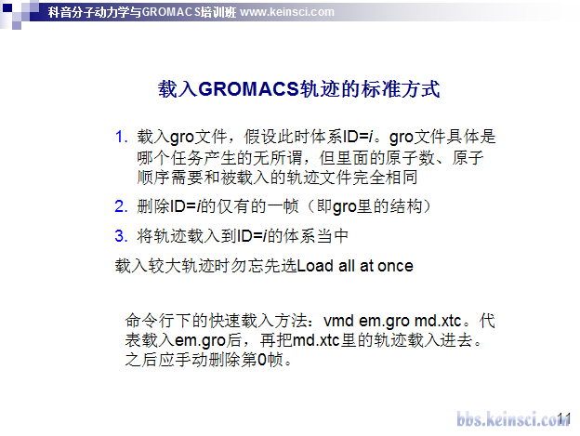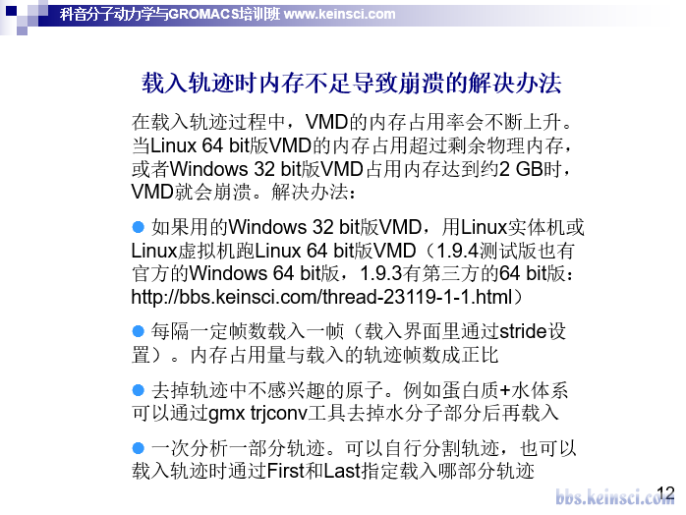

[如何用VMD保存和查看gromacs的模拟轨迹 - 分子模拟 (Molecular Modeling) - 计算化学公社 (keinsci.com)](http://bbs.keinsci.com/thread-18136-1-1.html)

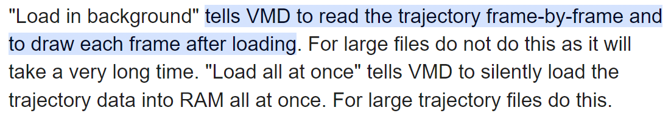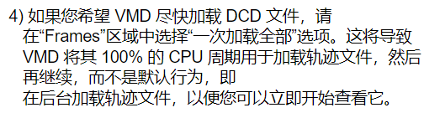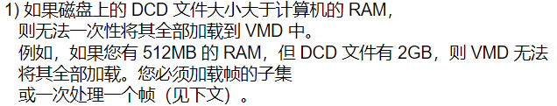

load at once

load in the background

<https://www.ks.uiuc.edu/Research/vmd/mailing_list/vmd-l/4599.html>

